**Comparing and Contrasting Linear and Exponential Functions**

Name __________________________

|  |  |  |
| --- | --- | --- |
|  | **Linear** | **Exponential** |
| **Rate of Change** |  |  |
| **Explicit Equations** |  |  |
| **Recursive Equations** |  |  |
| **Tables** |  |  |
| **Graphs** |  |  |

Exponential functions that are increasing will eventually exceed a quantity increasing linearly.

Examples:

1. Compare $f\left(x\right)=2*3^{x}$ and $g\left(x\right)=3x+2$
2. Compare $f\left(x\right)=6*{\frac{1}{3}}^{x}$ to the graph of $g(x)$ to the right.
3. What type of function best describes the following situations? Explain your answers.
   1. Marcus invests $1000 into a bank account that earns 3% interest annually. He has not taken out any money or added any money to his account since he deposited the original $1000.
   2. Ginny has $1000 that she keeps in her piggy bank at home. She never spends any of this money but she does add $50 to her piggy bank every year.
   3. Will Ginny always have more money than Marcus?

Independent Practice

Decide whether or not the following are linear or exponential.

|  |  |  |  |  |  |  |
| --- | --- | --- | --- | --- | --- | --- |
| x | 0 | 1 | 2 | 3 | 4 | 5 |
| y | 2 | 4 | 6 | 8 | 10 | 12 |



|  |  |  |  |  |  |  |
| --- | --- | --- | --- | --- | --- | --- |
| x | 0 | 1 | 2 | 3 | 4 | 5 |
| y | 2 | 6 | 18 | 54 | 162 | 486 |

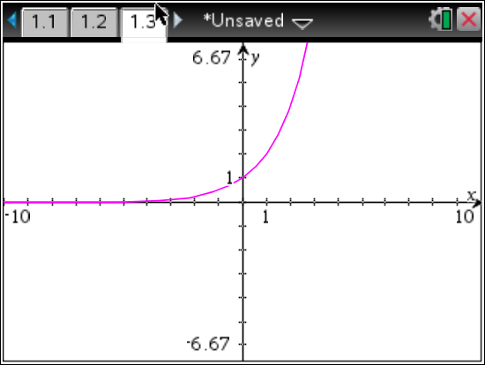

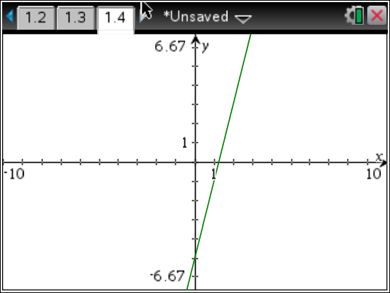

$f\left(x\right)=10*5^{x}$

$g\left(x\right)=3x-6$

2. John convinced his parents to pay him an allowance of 1 penny the first week 2 pennies the second week, 4 pennies the third week, and then to continue to double his allowance every week.
3. Sarah also convinced her parents to increase her allowance each week, but they would only agree to a 5 cent increase each week. She was already getting $5 a week. So the first week after her allowance was increased she received $5.05, and the week after that she received $5.10.