CCM8 Creating Scatter Plots
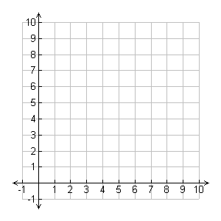
To create a scatter plot you have to start with a coordinate plane. A coordinate plane has an x and y axis and is used for graphing bivariate data. Bivariate data is data that has _______ variables.
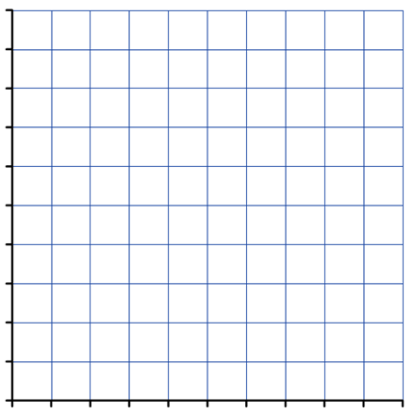
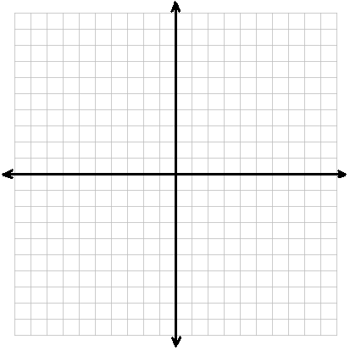

Example 1:
Data that relates the number of pets a student has to the
average number of texts that they send each day.
Create a scatter plot.
Student | 1 | 2 | 3 | 4 | 5 | 6 | 7 | 8 | 9 | 10
Number of Pets | 2 | 1 | 0 | 3 | 2 | 5 | 3 | 0 | 1 | 4
Number of Texts | 60 | 50 | 20 | 45 | 0 | 10 | 15 | 70 | 30 | 55

Example 2:
This data is from a survey that asked students how long they
spent on math homework every night and their grade in math
class. Create a scatter plot.
Student | 1 | 2 | 3 | 4 | 5 | 6 | 7 | 8 | 9 | 10
Time in Minutes | 20 | 30 | 0 | 40 | 25 | 15 | 10 | 45 | 30 | 25
Math Grade | 87 | 90 | 60 | 91 | 87 | 85 | 80 | 94 | 95 | 93

Example 3:
Data was collected from a local group that meets once a month
to clean up trash at a local park. They recorded the amount of
time that it took to clean up the park and the number of volunteers
that they had working that day. Create a scatter plot.
Number of workers | 10 | 8 | 7 | 12 | 5 | 8 | 6 | 9
Time in hours | 4 | 2.1 | 2 | 1.6 | 2.6 | 2 | 2.4 | 1.9

Example 4:
Data was collected over the years to keep track of how many tons of material was recycled each year. Create a scatter plot.
Source: http://www.epa.gov/epawaste/facts-text.htm#chart3
Year | 1960 | 1965 | 1970 | 1975 | 1980 | 1985 | 1990 | 1995 | 2000 | 2005 | 2010
Recycled Material | 5.6 | 6.5 | 8.0 | 9.3 | 14.5 | 16.7 | 33.2 | 55.8 | 69.5 | 79.9 | 85.1

Independent Practice
- Data from the first 10 games for a baseball team is
provided in the table. Create a scatter plot.
Game | 1 | 2 | 3 | 4 | 5 | 6 | 7 | 8 | 9 | 10
Hits | 10 | 8 | 15 | 18 | 12 | 9 | 7 | 9 | 14 | 15
Runs Scored | 4 | 3 | 7 | 6 | 5 | 4 | 1 | 2 | 8 | 6

- Data from the first 10 games for a basketball team is
provided in the table. Create a scatter plot.
Game | 1 | 2 | 3 | 4 | 5 | 6 | 7 | 8 | 9 | 10
Turnovers | 10 | 15 | 8 | 12 | 14 | 10 | 11 | 13 | 9 | 20
Points | 60 | 48 | 60 | 55 | 56 | 59 | 61 | 54 | 63 | 40

- Data that gives a bean plant’s height per day.
Create a scatter plot.
Day | 0 | 1 | 2 | 3 | 4 | 5 | 6 | 7 | 8 | 9 | 10
Height (cm) | 0 | 3.1 | 5.3 | 6.2 | 8.7 | 12.0 | 15.5 | 16.4 | 18.2 | 18.9 | 19.2

- Data that shows the population in Wake County since 1960. Create a scatterplot.
(source: http://www.wakegov.com/planning/demographic/documents/trends2012.pdf)
Year | 1960 | 1970 | 1980 | 1990 | 2000 | 2010
Population | 169,082 | 238,453 | 301,327 | 423,380 | 627,846 | 900,993

