 | Problem 1 | Problem 2 | Gridded Response
Monday | Covert $3.1\overline{6}$ to a fraction in simplest terms. | Circle the natural numbers.  $$-12$$  $$\frac{45}{15}$$  $$0$$  $$\sqrt{58-9}$$ | Problem 1  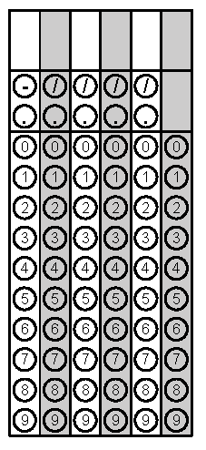
Tuesday | On a number line, point A is located at the largest integer less than $-\sqrt{23}.$Point B is located at the small integer that is greater than $\sqrt{32}.$ What is the distance between point A and point B? | Keisha charges a $1.75 flat rate to braid hair in addition to $0.75 per braid. Alena has no more than $10 to spend. How many braids can she get? | Problem 1
Wednesday | Two joggers run 8 miles north and then 5 miles west. What is the shortest distance, to the nearest tenth of a mile, they must travel to return to their starting point? | Describe the transformation below. | Problem 1
Thursday | Trapezoid G is the image after a rotation and reflection of the pre-image Trapezoid H. How many degrees was the pre-image rotated? | Solve the system. | Problem1
Friday | What is the value of  $$\frac{(3 ×{10}^{5})(4×{10}^{-7})}{(6×{10}^{-2})}$$ | The ice cream cone company is trying to decide how much space will fit inside their Guinness Record Breaking ice cream cone. If the height of the cone is 240 cm and the diameter is 398 cm, about how many cubic centimeters of ice cream can the cone hold? Use 3.14 for π. | Problem 1
Questions adapted from Score21 and SchoolNet

