 | Problem 1 | Problem 2 | Gridded Response
Monday | Triangle XYZ contains the points X (-3, 7), Y (6, 9), Z (3, 7). What will the coordinates of Z’ after a dilation with a scale factor of 4? | Shopper 1 is spending money at the rate of y = -75x. Shopper 2 is spending money at the rate below.  What is the difference in their spending per hour? | Problem 2  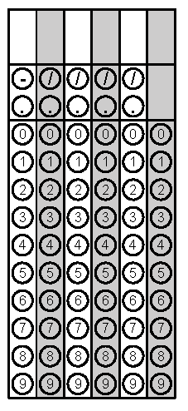
Tuesday | Find the perimeter of Parallelogram ABCD. | Given the pre-image points D(3, 1), E(-3, 2), and  F (-2, -2); what are the coordinates of the image after a translation of  (x, y) -> (x -5, y + 2), then a rotation of 90° counter clockwise. | Problem 1
Wednesday | The two rectangles below are similar. Find the value of x. | Given DEF with D (5, -2), E (-3, 4), and F (-5, -6). Find the image points after:  A reflection over the y axis, then a translation of  (x, y) → (x + 1, y – 4). | Problem 1
Thursday | Write the equation of the linear function.  What is the sum of the slope and y-intercept? | Given in the table are the samplings of average annual temperatures collected at different elevations in the United States.  Elevation (meters) Average Annual Temp (°C)  1,000 15  490 20  2,200 8  650 17  1,750 8  1,500 12.5  800 18  1,400 15  2,000 10  1,200 12  What type of correlation exists between these two data sets? | Problem 1
Friday | Graph the line $y=-\frac{2}{3}x+4.$ | Point A was translated from (-12, 9) to A’ (3, 4). How many units was the point translated on the x-axis? | Problem 2
Questions adapted from Score21 and SchoolNet

