 | Problem 1 | Problem 2 | Gridded Response
Monday | Determine the scale factor of the dilation below. | Concessions at a basketball game cost $1 for a bag of chips and $2.50 for nachos At the end of the night, 188 items are sold for a total of $305. How many bags of chips are sold? | Problem 1  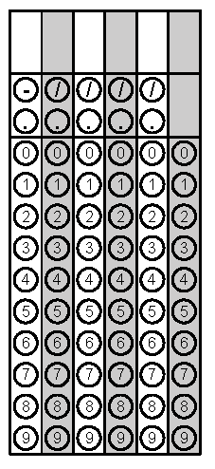
Tuesday | Solve for b.  $$a^{2}+b^{2}=c^{2}$$ | Based on the line of best fit, what would be the store profit if they sold 30 Air Jordan’s | Problem 2
Wednesday | Summer is planning to take aerobics classes at a gym. Non-members pay $8 per class, while members pay $4 per class and a $20 membership fee. If Sarah plans to take 6 aerobics classes, should she become a member of the gym? Explain why or why not? | A triangle with the coordinate X (-2, 2), Y (0, 7), and Z (3, 4) is reflected across the x-axis. What is the y value of the new coordinate Z’? | Problem 2
Thursday | Rectangle EFGH was translated 5 units up and 3 units left. What will the coordinates of E’ be after the translation? | One of the angles in a right triangle measures 37 degrees. What is the measure of the missing angle? | Problem 2
Friday | The Montague Family had to build a wheelchair ramp for their grandfather. What is the slope of the ramp? | Rotate triangle ABC clockwise 90° about the origin. What are the new ordered pairs after the rotation?  ΔABC ΔA′B′C′  A(1, 3) A′  B(2, 1) B′  C(1, 1) C′ | Problem 1
Questions adapted from Score21 and SchoolNet

