 | Problem 1 | Problem 2 | Gridded Response
Monday | The length of a rectangle is 2 centimeters more than 3 times the width. If the perimeter of the rectangle is 36 centimeters, what is the length of the rectangle? | A lines passes through the points (-4, 0) and (-4, -8). What is the slope of the line? | Problem 1  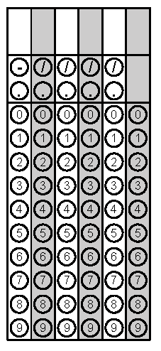
Tuesday | Find the perimeter of the triangle to the nearest tenth. | Simplify: | Problem 1
Wednesday | A skate park charges a $30 joining fee plus $6 for each visit. Jaylen has spent a total of $402 at the skate park this year. Use an equation to find how many visits he has made. | The sum of two numbers is 80. Their difference is 44. Write a system of equations that describes this situation. What are the two numbers? | Problem 1
Thursday | Ten years ago the price of a 16-ounce bag of potato chips was $3.44. The current price of the 16-ounce bag is $4.74. Write linear equations to represent this situation.  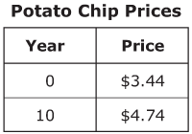 | Find the sum of the y-intercepts of the two linear functions below.  $y=\frac{3}{5}x-6$ and | Problem 2
Friday | Write a situation comparing two data sets that have a negative correlation. | Lucas compared the y-intercepts of two functions.  - y = 7x – 4  What is the distance between the y-intercepts of the two functions? | Problem 2
Questions adapted from Score21 and SchoolNet

