 | Problem 1 | Problem 2 | Gridded Response
Monday | The perimeter of a square is 25 inches. Would the area of this square be rational or irrational? | Alan received $50 for his birthday. He then saved $15 per week until he had a total of $305 to buy a video game system. Write and solve an equation to show how many weeks it took him to save the money. | Problem 2  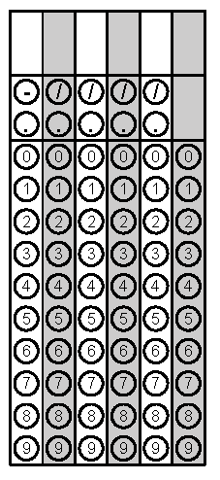
Tuesday | A 50ft. cable is stretched from the top of an antenna to an anchor point on the ground 15 ft. from the base of the antenna. How tall is the antenna? Round the nearest tenth. | What is the solution of the system of equations?  y = –2x + 6  y = $\frac{5}{3}x$– 5  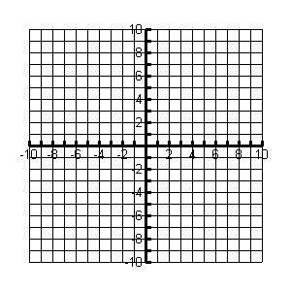 | Problem 1
Wednesday | Describe the correlation between cost of a gym membership and the number of new memberships sold. | Sally bought three plastic cones, shown below, to use for her school project. Find the approximate volume of the three cones to the nearest cubic centimeter. | Problem 2
Thursday | The burning rate of candles of Store A can be described as $y=-\frac{5}{2}x+10.$  The burning rate of candles at Store B is given in the table.  Which candle would you buy if you want to buy the slowest burning candle? | The points (–5,–3) and (–5, 9) are adjacent vertices of a rectangle. Two of the sides of the rectangle have a length of 5 units. What is the length of a diagonal of the rectangle? | Problem 2
Friday | Find the sum of x and y.  6x – 2y = 6  y = 2x + 5 | Students at a middle school conducted a survey on pet ownership. About what percent of students surveyed own cats and dogs? | Problem 1
Questions adapted from Score21 and SchoolNet

