 | Problem 1 | Problem 2 | Gridded Response
Monday | Evaluate  $$\sqrt{121}∙0.\overline{27}$$ | Which ordered pair could be removed from the set  {(-2, 5), (4, -5), (3, -6),  (-2, 8), (1, -7)} so that the relation represents a function? Explain your answer. | Problem 1  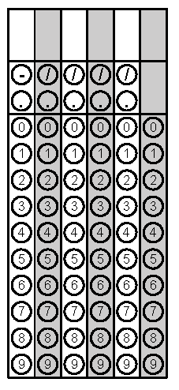
Tuesday | Two angles of a triangle have the same measure. The sum of the measures of these angles is one-half the measure of the third angle. Find the measures of the angles of the triangle. | Determine the slope of the line that passes through the points below. | Problem 2
Wednesday | Identify the slope of the line below. | Explain why the equation  x = 10 is not a function. | Problem 1
Thursday | Does the diagram of the relation below represent at function? | Jane is buying Apps for her iPhone. She can buy 5apps and have $3 left on her iTunes Gift Card or using the same amount she can by 2apps and have $9 left on her Gift Card. Write and solve an equation to find the cost of one app. | Problem 2
Friday | Two candles are burning.  - Candle A burns at a rate of 2 inches per hour.  - Candle B burns at a rate of y = -2.5x +10.  Which candle would you purchase if you want to buy the candle that burns the slowest? | Evaluate  $$\frac{2^{5}∙2^{7}∙3^{4}}{2^{9}∙3^{2}∙3^{5}}$$ | Problem 2

