 | Problem 1 | Problem 2 | Gridded Response
Monday | Find the value of x. | A triangle has side measurements of 15 cm, 20cm, and 25 cm. Is the triangle a right triangle? | Problem 1  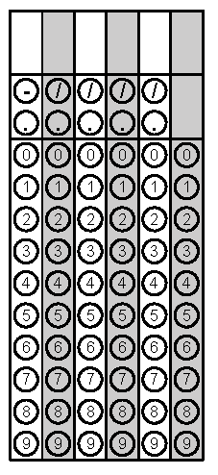
Tuesday | Sarah graphed the points  (-4, 8), (-2, 5), (-1, 6), and  (-2, 3). Is this a function? | What is the rate of change of the table below? | Problem 2
Wednesday | Hunter is filling his swimming pool with water. Write a description of what is happening in the graph below. | A cone has a radius of 10 inches and a height of 20 inches. Find the approximate volume of the cone to the nearest tenth. Use 3.14 for π. | Problem 2
Thursday | Andy wants to purchase a car that has the best gas millage rate.  - Car 1 has gas mileage that can be described as y = 18x, where x is the number of gallon of gas used and y is the total miles driven.  - Car 2 has he gas mileage rate displayed in the table below.  Which car should Andy buy? How many more miles per gallon can he drive with this car? | Approximate the value of $-\sqrt{32}$to the nearest hundredth. | Problem 2
Friday | The length of a rectangle is 5 centimeters less than twice the width. The perimeter of the rectangle is 26 cm. What are the dimensions of the rectangle? | Using the equation  $$\frac{4^{x}}{4^{y}}=\frac{1}{4^{6}}$$  find the value of x if y = 12. | Problem 2

