 | Problem 1 | Problem 2 | Gridded Response
Monday | The surface area of North America is approximately 9,355,000 square miles. Write this value in scientific notation. | Fourteen less than the quantity of a number times five is the same as the product of eight and the number increased by four. What is the number? | Problem 2  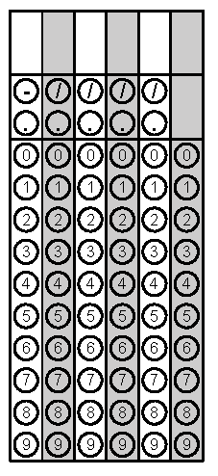
Tuesday | A cylinder is 15 inches long and has a diameter of 7 inches. What is the volume of the cylinder in terms of pi? | What is the area of the triangle shown below? | Problem 2
Wednesday | Evaluate  $$-5\sqrt{225-56}+\sqrt[3]{64}-\sqrt{16}$$ | Convert $0.2\overline{34}$ to a fraction. | Problem 1
Thursday | Find the approximate volume of the sphere below to the nearest tenth of an inch. Use 3.14 for π. | The measure of one angle of a triangle is twice the measure of a second angle. The measure of the third angle is 12 less than the sum of the other two. Find the measure of the angles of the triangle. | Problem 1
Friday | What is the measure of the largest exterior angle of the triangle below?  30° | The points (4, -2) and  (-2, -2) are adjacent vertices of a rectangle. Two of the sides have a length of 8 units. What is the diagonal length of the rectangle? | Problem 1
http://www.britannica.com/EBchecked/topic/418612/North-America

