 | Problem 1 | Problem 2 | Gridded Response
Monday | In Yahtzee, you play with five dice. All the dice are the same size. If the total volume of all five dice is 320 cubic centimeters, how long is each side of a single die? | The angles of a triangle measure 83º, 48º, and 49º. What is the measure of the smallest exterior angle of the triangle? | Problem 1  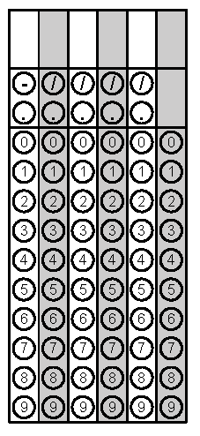
Tuesday | Place the following numbers in order from greatest to least. Classify each number as rational or irrational.  $\sqrt{35}$  $6$  $\frac{38}{6}$  $5.3$ | Find the area of the triangle. | Problem 2
Wednesday | What is the value of  $$\frac{4^{5}∙4^{-3}∙5^{4}}{4^{4}∙5^{6}∙5^{-5}}$$ | Michael’s Videos charges members $4 to rent each video. If you get a store membership it costs $20 and members only pay $2 to rent a video. For what number of videos is the cost the same? Write and solve an equation. | Problem 1
Thursday | Jonah ate $\frac{5}{8}$ of a pizza. Ben ate $0.\overline{6}$ of a pizza. Who ate more pizza? How much more did they eat? | Arianna is moving to college and has many items she wants to take with her. She has decided to pack some of her items in a crate the shape of a cube. If one side of the crate is 2.3 feet in length, how much of Arianna’s stuff will the crate hold (in cubic feet)? | Problem 1
Friday | Solve for w.  $$P=2(l+w)$$ | Line x and line y are parallel. They are cut by transversal s and transversal t. Find the value of m. | Problem 2
Questions adapted from Score21 and SchoolNet

