 | Problem 1 | Problem 2 | Gridded Response
Monday | Solve for x.  $$216x^{3}=27$$ | Write an expression, using multiplication, that is equal to $12x^{24}.$ | Problem 1  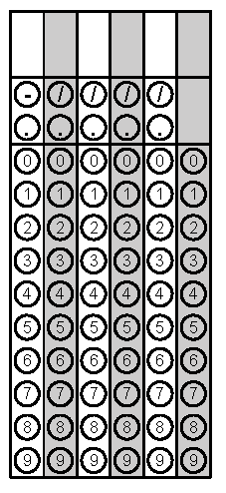
Tuesday | Solve for y.  $$4x-5y= -75$$ | Simplify  $$3\sqrt{\frac{16}{9}}-5$$ | Problem 2
Wednesday | Triangle ABC is similar to triangle DEF.  - Triangle ABC is a right triangle.  - m<A = 4xº  - m<B = x + 5º  - m<C = 90º  What is the angle measure of the smallest angle of Triangle DEF? | Solve for x.  $$\frac{2}{3}\left(6x+12\right)+2x=-2x+8(x+1)$$ | Problem 1
Thursday | What are the two square roots of…  $$\sqrt{-10+35}$$ | Emma received an iTunes gift card for her birthday. All the apps she wants to purchase are the same price. She can buy four apps and have three dollars left over or she can buy two apps and have eleven dollars remaining. How much is each app? | Problem 2
Friday | Approximate $-\sqrt{132}$ to the nearest hundredth. | Solve for b.  $$a^{2}+b^{2}=c^{2}$$ | Problem
Questions adapted from Score21 and SchoolNet

