 | Problem 1 | Problem 2 | Gridded Response
Monday | What is the value of the expression?  $$\frac{2^{-5}}{2^{-9}}∙2^{-2}$$ | The length of one side of a triangle is $3\sqrt{2.}$ Is the length rational or irrational? Explain your answer. | Problem 1  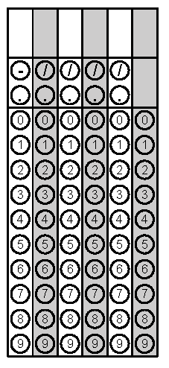
Tuesday | Find the product of  0.002 x 5,000,000 x 0.00006.  Write your answer in scientific notation. | Find the value of x. Write your answer in simplest form.  $$x^{2}=\frac{36}{81}$$ | Problem 2
Wednesday | A gym membership charges an initial fee of $ 125 plus a $25 fee every month. Another gym only charges $50 every month. After how many months will the total cost for both gyms be the same? | The number of fish in Lake Jordan is about 2.5 × 10⁸. The number of fish in Falls Lake is about 5 × 10⁴. How many fish are in the lakes altogether? | Problem 1
Thursday | Simplify  $$0.\overline{24}∙\frac{3}{8}$$ | A rectangle has a perimeter of 48 inches. The length of the rectangle is four more than four times the width. What is the area of the rectangle? | Problem 1
Friday | Lines x and y are parallel. The measure of angle 2 is 3s- 4 and the measure of angle 7 is 2s + 3. Find the value of s. | Amy is planting flowers in her yard. She buys 20 pansies and 5 mums, which cost a total of $52.50. If mums cost three times as much as pansies, how much does each type of flower cost? | Problem 1
Questions adapted from Score21 and SchoolNet

