 | Problem 1 | Problem 2 | Gridded Response
Monday | What is the value of the expression?  $$\frac{8.1 × {10}^{-4}}{0.09}$$ | What is the sum of the integers between $\sqrt{8}$ and $\sqrt{47}?$ | Problem 2  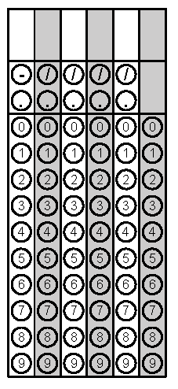
Tuesday | On a number line, Point A represents the smallest integer value greater than $\sqrt{45.}$ Point B represents the largest integer that is less than $-\sqrt{15.}$ What is the distance between point A and point B? | Simplify:  $$\frac{{(4ab^{3})}^{2}}{8a^{4}∙a^{5}}$$ | Problem 1
Wednesday | The diameter of one strand of human hair is about  1 x 10⁻³ inches. What is the diameter of a pony tail made of 100,000 strands of hair? | The area of a chessboard is 64 squares. What is the perimeter of the chessboard? | Problem 2
Thursday | Evaluate  $$3\sqrt{16}+\sqrt{49}-\sqrt{125-4}$$ | The recipe for a dozen biscuits is below. If Monica needs to bake 30 biscuits, how much flour should she use? Write as an improper fraction.  $2\frac{1}{2}$ c. flour  $\frac{1}{2}$ c. butter  $1\frac{1}{4}$ c. buttermilk | Problem 2
Friday | Evaluate. Leave as an improper fraction.  $$\frac{{(2^{3})}^{2}∙3^{2}}{3^{4}}$$ | How many times larger is  9 x 10⁷ compared to  3 x 10⁵? | Problem 1
http://hypertextbook.com/facts/1999/BrianLey.shtml
Questions adapted from Score21 and SchoolNet

