 | Problem 1 | Problem 2 | Gridded Response
Monday | Express $2.1\overline{6}$ as fraction. | Identify the following as rational or irrational.  $$-\frac{3}{9}$$  $$\frac{π}{3}$$  $$5.78$$ | Problem 1  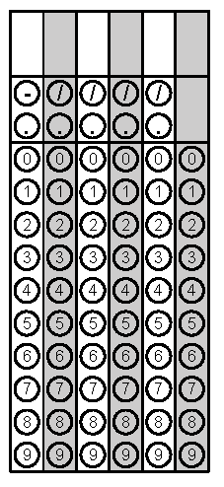
Tuesday | What is the value of  $\frac{9}{11}∙0.\overline{22}$? | Simplify $\frac{a^{-2}b^{5}}{c^{3}d^{-7}}$ | Problem 1
Wednesday | List the following numbers in order from least to greatest.  $-\sqrt{15}$ $-4.5$ $-\frac{12}{3}$ | Tammy is building a square vegetable garden. She is going to put cedar timbers along the border of her garden. Each timber is 5 feet. If Tammy wants the area of the garden to be 225 square feet, how many timbers should Tammy buy? | Problem 2
Thursday | The distance from the Sun to Mercury is 3.5 x 10⁷ miles. There are 48 million miles between Mercury and Earth. How far is Earth from the Sun? | Approximate $\sqrt{50}$to the nearest hundredth. | Problem 2
Friday | Convert $\frac{7}{8}$ to a decimal. | Circle the irrational numbers  $$\sqrt{32}$$  $$0.1121231234 . . .$$  $$\frac{4π}{π}$$  $$7^{-2}$$  $$3\sqrt{10}$$ | Problem 1
http://www.universetoday.com/15462/how-far-are-the-planets-from-the-sun/
Questions adapted from Score21 and SchoolNet

