 | Problem 1 | Problem 2 | Gridded Response
Monday | Convert to standard notation. 1.26 x 10⁵ | Jim ate $\frac{4}{9}$ of the pizza. Jane ate $\frac{1}{5}$of the pizza. How much did they eat altogether? | Problem 2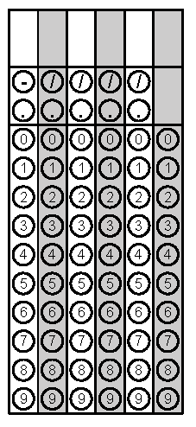
Tuesday | What would be the best measurement for the amount of water a cat drinks in a day:  Gallons or Fluid Ounces? | Find the sum of the integers between $-\sqrt{50 }$ and $\sqrt{20}.$ | Problem 2
Wednesday | Estimate $-\sqrt{52}$to the nearest tenth. | Simplify  (2xy)³ | Problem 1
Thursday | Circle the whole numbers.  $$\frac{-12}{-4}$$  $$0$$  $$-7$$  $$\frac{5π}{π}$$ | Simplify.  $\sqrt{64-15}$ − $\sqrt{16}$ | Problem 2
Friday | Evaluate  $$(3^{2})(3^{-4})$$ | Convert to a fraction.  $$3.\overline{33}$$ | Problem 1
Questions adapted from Score21 and SchoolNet

