 | Problem 1 | Problem 2 | Gridded Response
Monday | Simplify  $$3\sqrt{16}-\sqrt{100-64}+3$$ | Juan is measuring the length of his house. He finds it is $32.\overline{5 }$ feet long. Write this value as a fraction. | Problem 2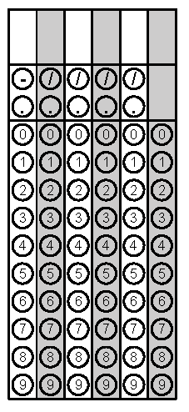
Tuesday | Circle the rational numbers.  $$-\frac{7}{9}$$  $$\sqrt{47}$$  $$\frac{-7π}{π}$$  $$4\sqrt{150-6}$$ | Simplify  $$\frac{3^{-2}}{3^{-5}}$$ | Problem 2
Wednesday | James is moving to college. He has seven cubic crates to back his things. Each cube has a side length of 2 feet. What’s the total volume of all seven crates? | One side of a pentagon measures $\sqrt{30} inches.$ What is the measure of this side as a decimal to the nearest hundredth? | Problem 2
Thursday | Simplify  ${(a^{2}bc^{-2})}^{0}∙a^{5}$ | Collins is helping her teacher decorate a square bulletin board. The area of the board is 225 square inches. How many inches of border does Collins need to go around the bulletin board? | Problem 2
Friday | Simplify  $$\frac{3}{4}∙0.\overline{8}$$ | Circle the natural numbers.  -7  $$4\sqrt{9}$$  $$0$$  $$\frac{15}{5}$$ | Problem 1
Questions adapted from Score21 and SchoolNet

