 | Problem 1 | Problem 2 | Gridded Response
Monday | Kyle is making a model airplane. He is using the scale $\frac{1}{4}in. =4feet.$ If the actual length of the plane’s wing is 64 feet; how long should the wing be in his model? | Rita is making cakes. In 5 cakes she uses $12\frac{1}{2}cups$ of sugar. How much sugar is in one cake? | Problem 2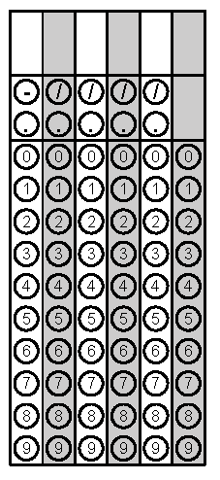
Tuesday | Solve for x.  $$3x+5=29$$ | Simplify  $$-\left(2a-4b\right)-5\left(b+6a\right)$$ | Problem 1
Wednesday | Jacob earned the following amounts the last three weeks. How much does Jacob earn per hour? | Jeff is painting lines on a basketball court. What is the area inside the lines?  Round your answer to the nearest square meter. | Problem 1
Thursday | What is the area of the non-shaded area to the nearest hundredth? | Food Lion grocery store advertises a special on 2-liter bottles of soft drinks. The first bottle purchased is $1.50 and each bottle after that is $1. Write an expression that can be used to find the total cost. Find the total cost if you purchase 5 bottles. | Problem
Friday | A triangular right prism is cut perpendicular to the base. What is the shape of the cross section? | When Sarah planted a tree in her yard it was 24 inches tall. It grew at a rate of 2.5 inches per month. The tree is now 41.5 inches tall.  How many months has it been since Sarah planted the tree? | Problem 2
Questions adapted from Score21 and SchoolNet

