 | Problem 1 | Problem 2 | Gridded Response
Monday | Sam spent $32.50 to take his girlfriend to the movies. He spent 40% on snacks and the remainder was spent on the two tickets. How much was each ticket? | The chart below shows how long Katherine spent on homework the last two weeks. What is the approximate difference in each week’s average? | Problem 1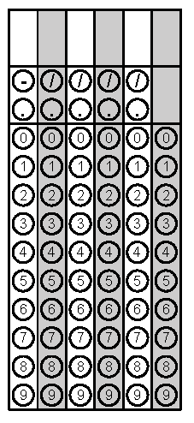
Tuesday | On a set of blueprints for a new home, the contractor has established a scale that states $\frac{1}{2}$ inch = 10 feet. What is the actual width of the living room whose distance is $\frac{3}{4}$inch on the blueprints? | Simplify  $$-3[4^{2}+{\left(\frac{1}{2}\right)}^{2}]$$ | Problem 2
Wednesday | Two stores have Blu-ray players on sale. Store A has the player on sale for 30% off the original price of $105.25. Store B has the player on sale for 20% off the original price of $89.95.  What is the difference in the sale prices? | Julie bought 4.5 pounds of apples to make a pie. The apples cost $6.75. How much does one pound of apples cost? | Problem 2
Thursday | Jennifer has three pieces of ribbon that measure 3 feet, 4 feet, and 8 feet. Without cutting the ribbon, can Jennifer make a triangle out of the pieces of ribbon? | What is the volume of this prism? | Problem 2
Friday | Simplify  $$-3\left(x+4\right)+5x+8$$ | Solve for x.  $$-18=-2-4x$$ | Problem 2
Questions adapted from Score21 and SchoolNet

