 | Problem 1 | Problem 2 | Gridded Response
Monday | A store sells candles.  •The retail price was a 45 percent markup over the manufacturer price.  •A month later, the store reduced the retail price of the candles by 20 percent.  What percent markup is the new retail price over the manufacturer price? | Angles X and Y are supplementary. Angle X measures 5x-6. Angle Y measures 141 degrees.  What is the value of x? | Problem 2  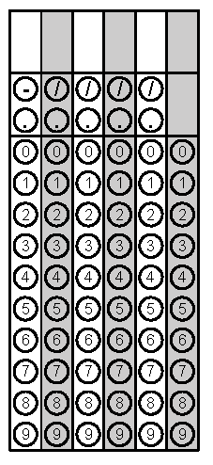
Tuesday | Kim is ordering a pizza online. She will randomly select one crust type, sauce, and topping.  Crust Type Sauce Toppings  Thin Red Sauce Cheese  Hand-Tossed White Sauce Pepperoni  Thick Sausage  What is the probably she will select thin crust, red sauce, and pepperoni? | Based on the table, write an equation to represent the dollars earned, d, for any amount of hours worked, w. | Problem 1
Wednesday | Cori saved $15 every week for 6 months. Then she spent 60% of the money for a new bike. How much money did she have left? | Allen made a scale drawing of his basketball goal. The basketball goal is 10 feet tall. In the drawing the basketball goal is 2.5 inches. What is the scale of the drawing? | Problem 1
Thursday | Martinique is playing Monopoly with her family. She is using two dice, numbered 1-6. What is the probability she will roll doubles (two of the same number)? | Simplify the expression  $$-4\left(2x-7y\right)+2(3y+8x)$$ | Problem 1
Friday | Josh took his girlfriend out to dinner for her birthday. Dinner was $74.96. Tax on the meal was 7.5% of the price of the meal. They left a tip that was 18% of the meal and tax. What is the total cost of the meal? | Solve for x.  $$\frac{x}{-4}+2>7$$ | Problem 1
Questions adapted from Score21 and SchoolNet

