 | Problem 1 | Problem 2 | Gridded Response
Monday | Suppose a dog can run 52 feet in 8 seconds. A cat can run 32 feet in 4 seconds. Which animal can run faster? How much faster? | Josiah purchased three cheeseburgers for $1.59 each and two milkshakes for $3.25 each. If sales tax is 7.25%, what is the total of Josiah’s purchase? Round to the nearest hundredth. | Problem 2  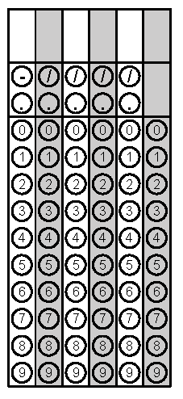
Tuesday | Below is the weight of five football players from each team. How much higher is the median weight of the Cardinals compared to the Steelers?  Cardinals Steelers  Mike Gandy 316 Max Starks 345  Reggie Wells 308 Chris Kemoeata 344  Lyle Sendlein 300 Justin Hartwig 312  Duece Luti 332 Darnell Stapelton 305  Levi Brown 322 Willie Colon 315 | Solve the inequality.  $$-4x-8≤56$$ | Problem 1
Wednesday | Tyler is laying tile on his rectangular kitchen floor. The dimensions of the floor are $16\frac{1}{2}feet$by $15feet.$ If he is using square tiles with a side length of $\frac{1}{2}feet$, how many tiles will he need to cover the floor? | What is the surface area of this figure? | Problem 2
Thursday | What is the difference between the students’ Mean Absolute Deviation?  Student Test 1 Test 2 Test 3 Test 4  Johnny 65 82 93 100  Will 82 86 88 84 | Johnathan’s bathroom is 7 feet by 5 feet. He is laying square tiles with a side length of 4 inches. How many tiles does he need? | Problem 2
Friday | Solve for x.  $$-10=-2x+4$$ | Steven has 24 t-shirts. One third of the t-shirts are white, one fourth of the  t-shirts are blue; the remainder of the t-shirts are orange. How many orange t-shirts does he own? | Problem 1
Questions adapted from Score21 and SchoolNet

