Pythagorean Theorem Notes Name _________________________

Pythagorean Theorem states that the sum of the areas of the two squares on the legs equals the area of the square on the hypotenuse.
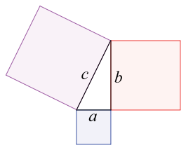

Determine if the side length will make a right triangle.

1. 20, 21, 29 2. 10, 15, 20 3. 45, 53, 28

Pause the video and try the problems on your own!
Then press play and check your answers with a color pen.

Determine if the side length will make a right triangle.

1. 7, 11, 12 2. 15, 20, 25 3. 30, 34, 16

